Programming II Assignment 3 GUI

Name: Thong Wei Yong

Matric: 279932

Home GUI

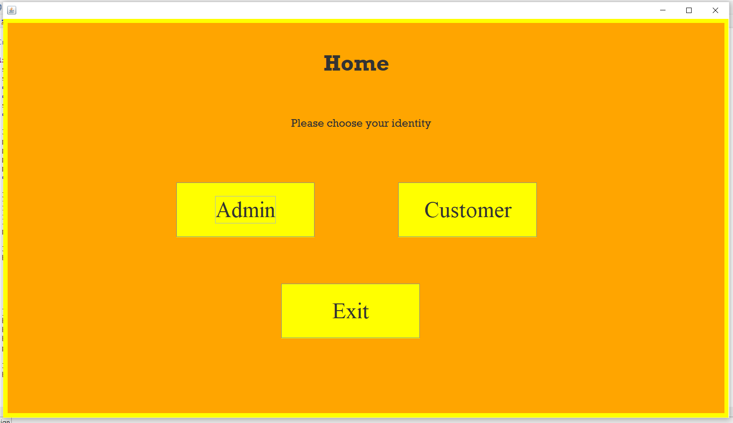

Login GUI if user is Admin

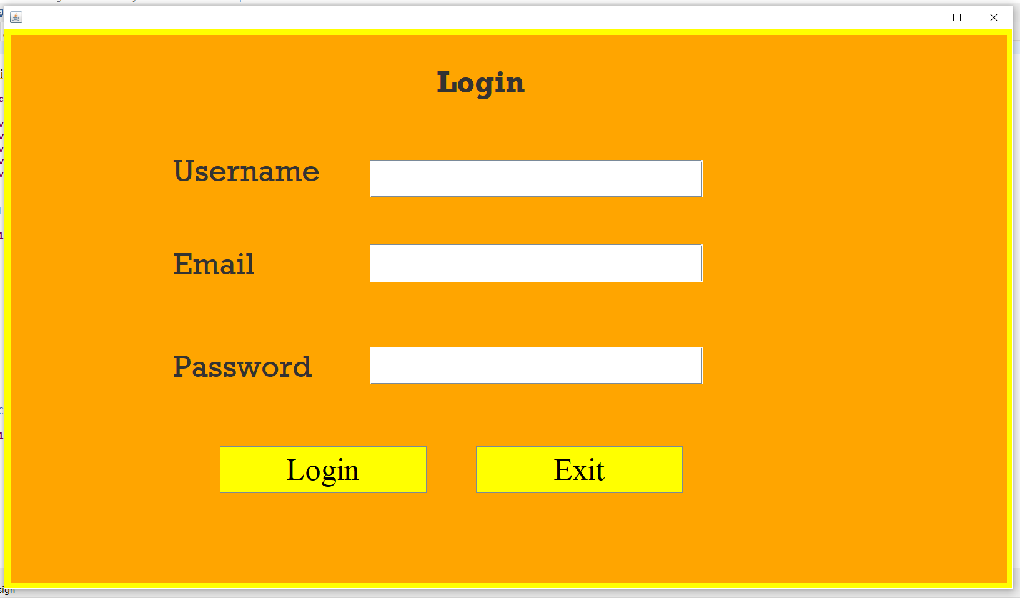

Admin Menu GUI if login success

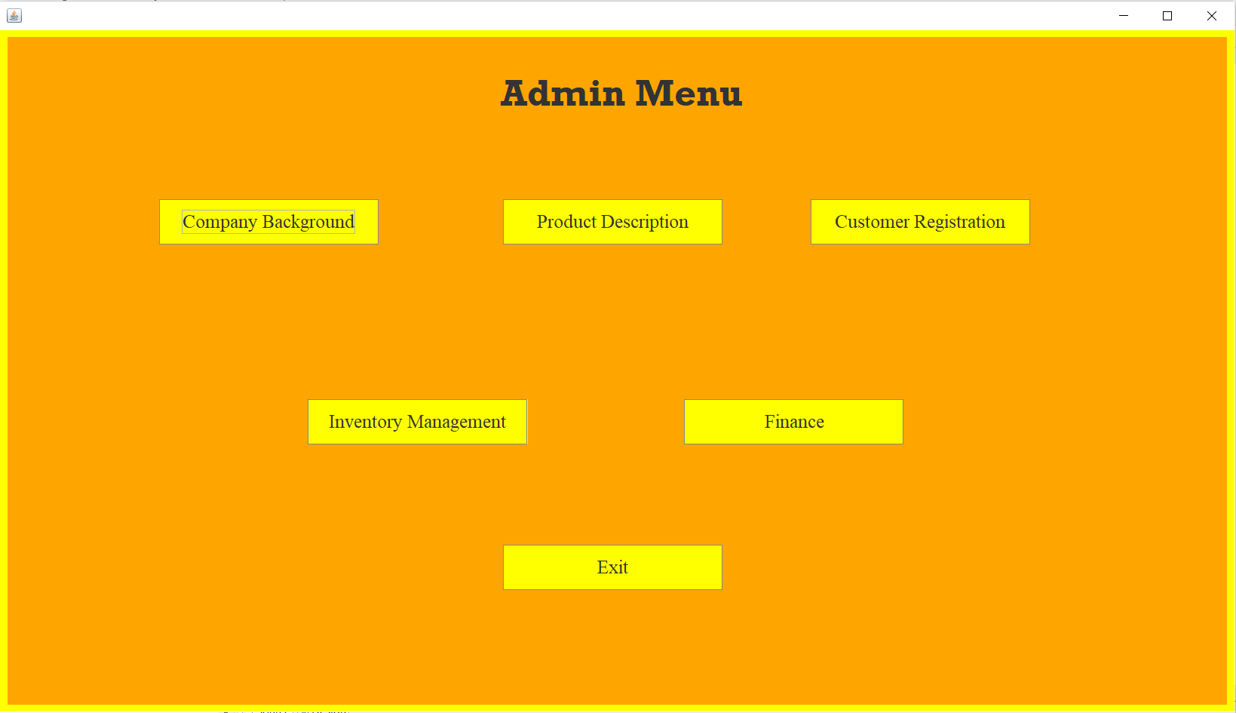

Company Background GUI

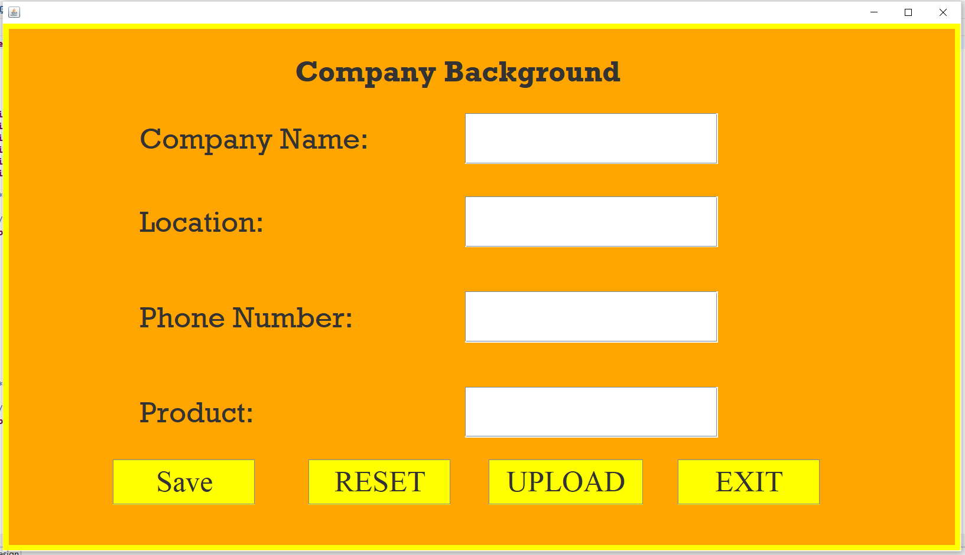

Product Description GUI  
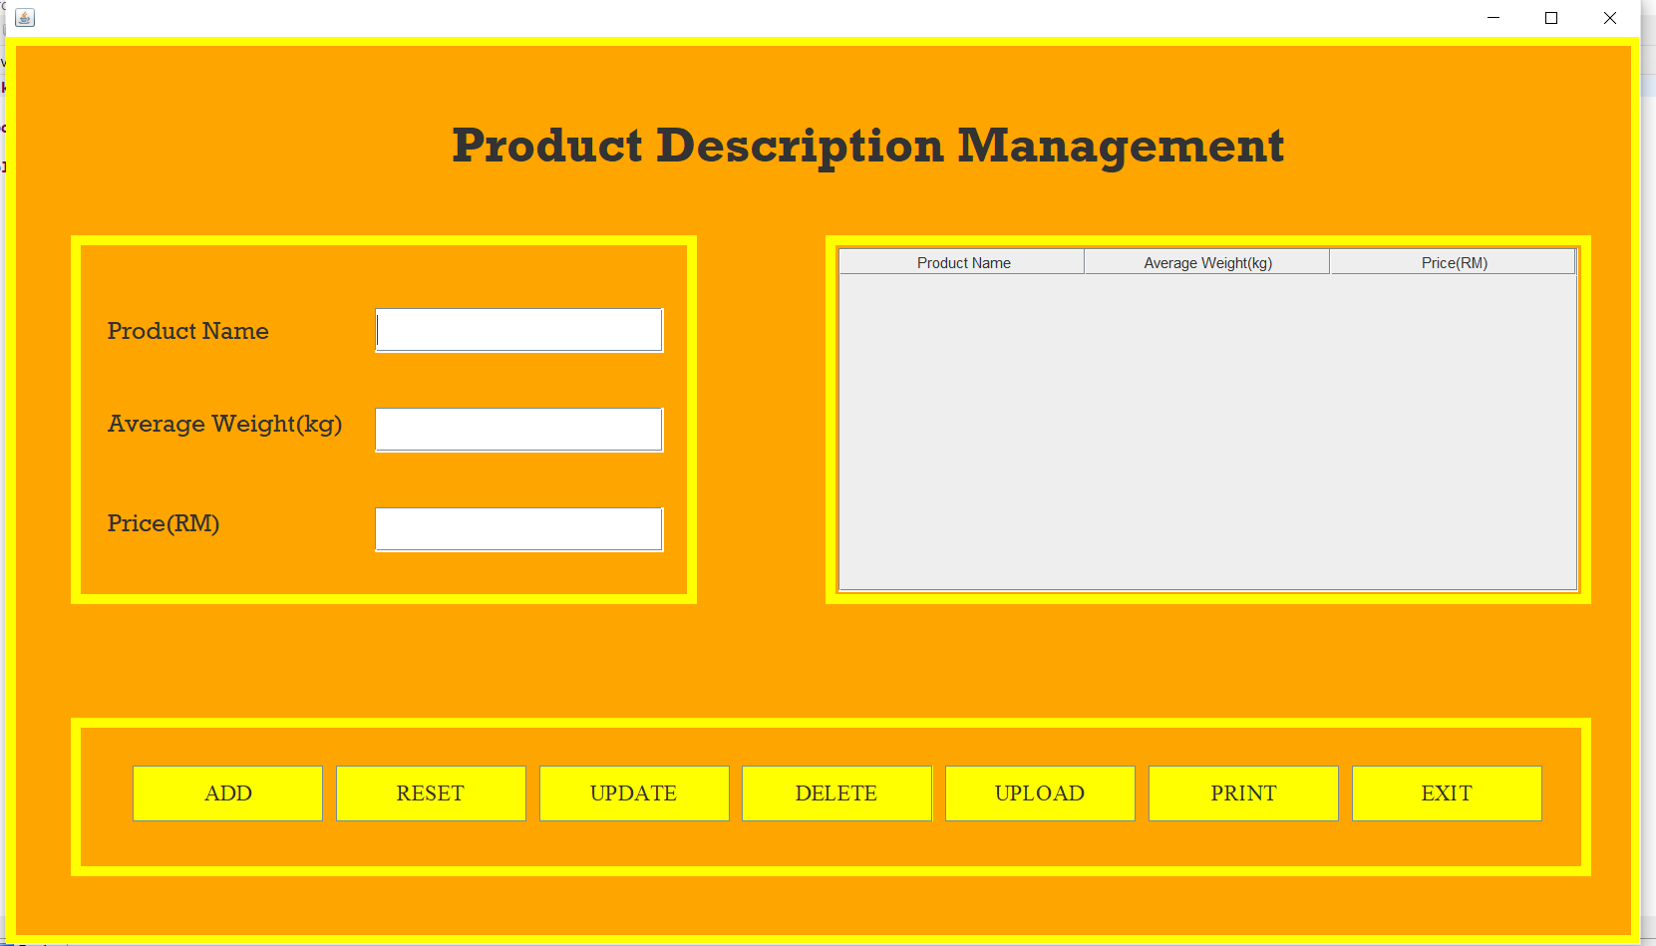

Customer Registration GUI

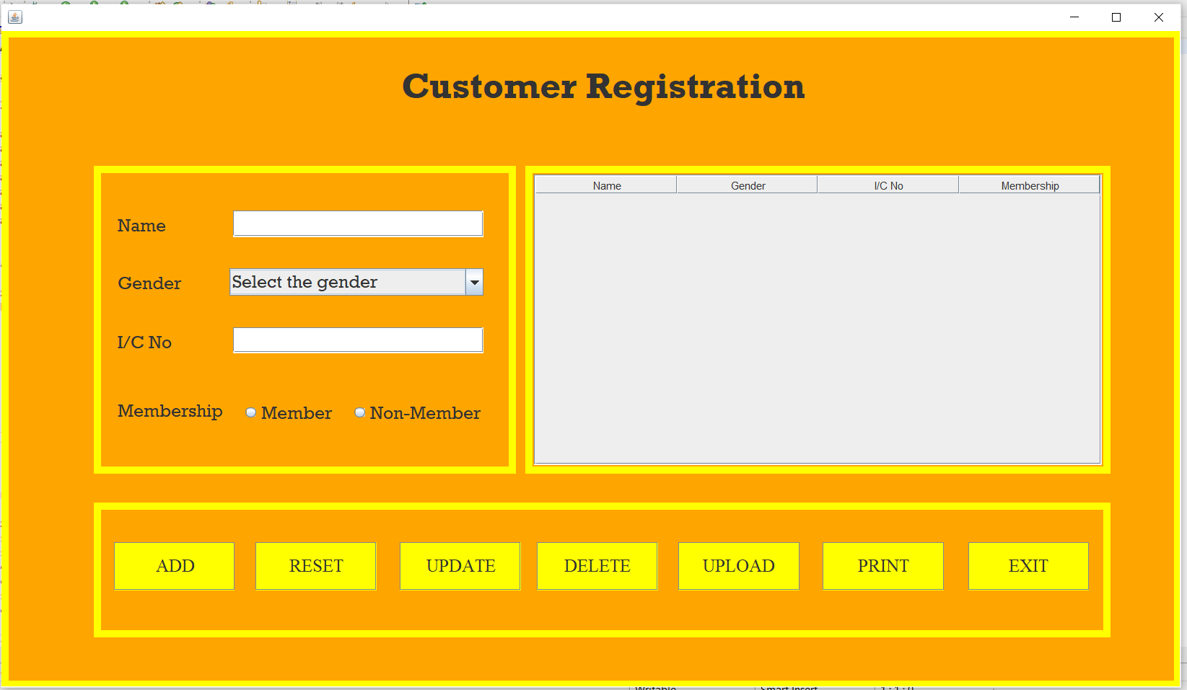

Inventory Management GUI

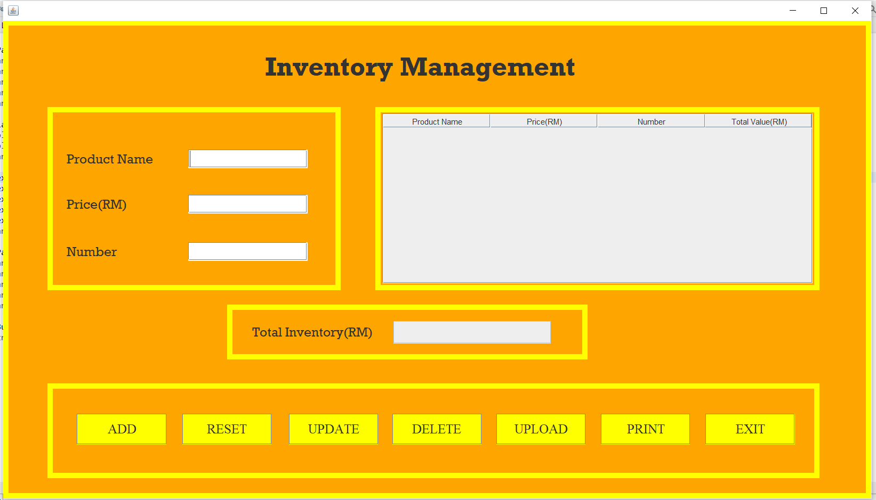

Choosing Finance at Admin Menu will first bring up Marketing GUI

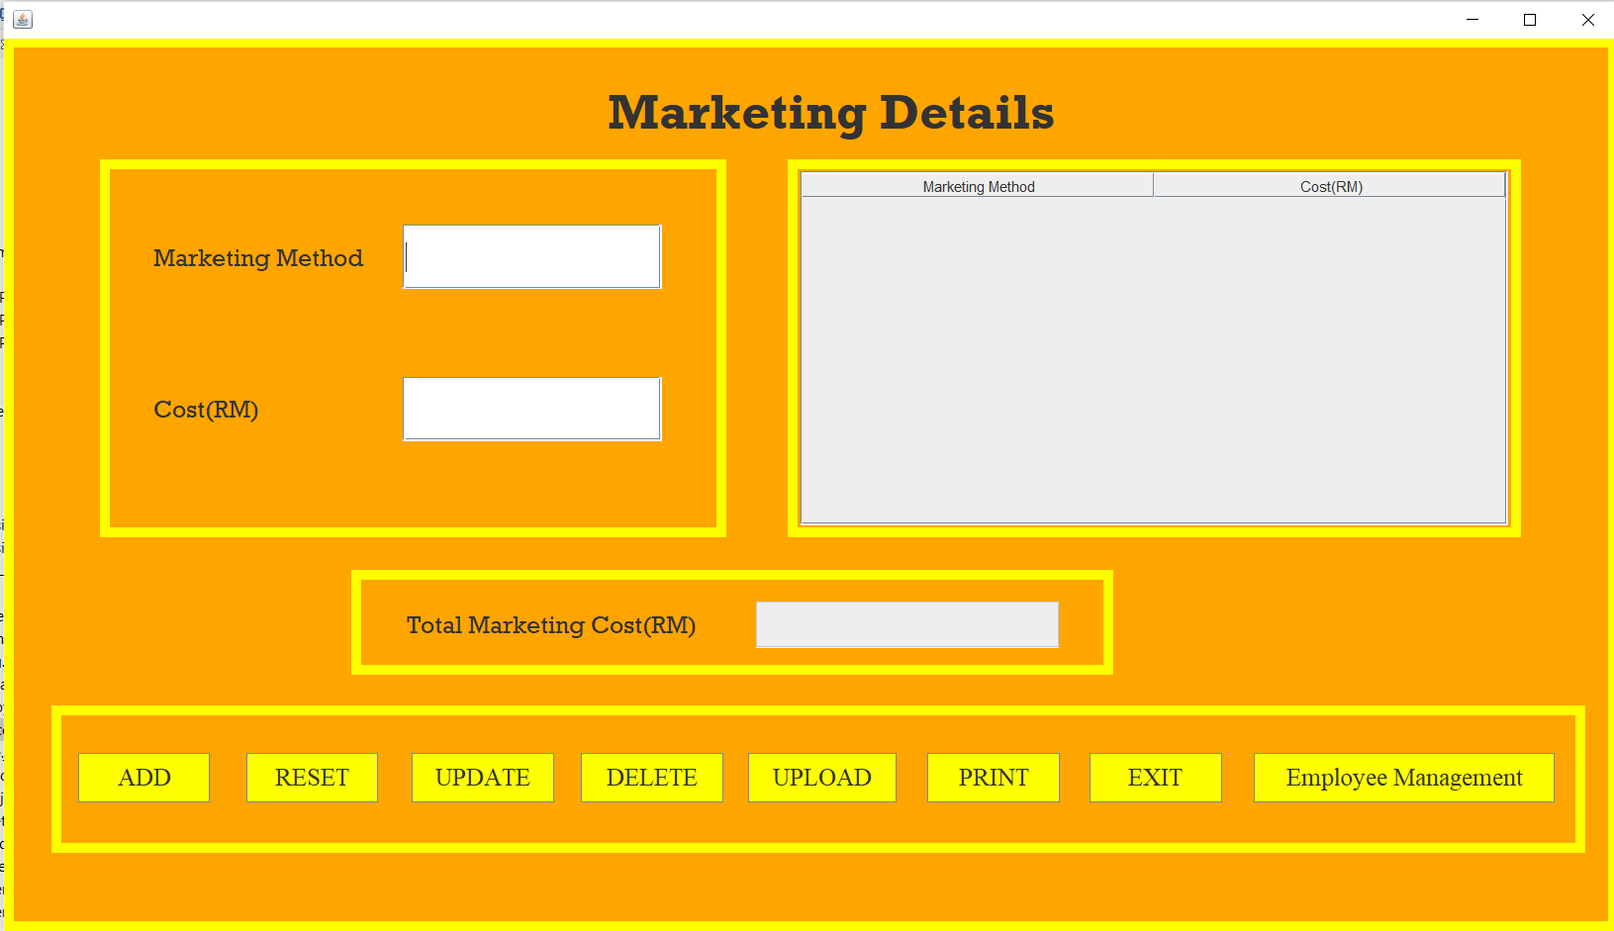

Choosing Employee Management button at Marketing will bring to Employee Management GUI  
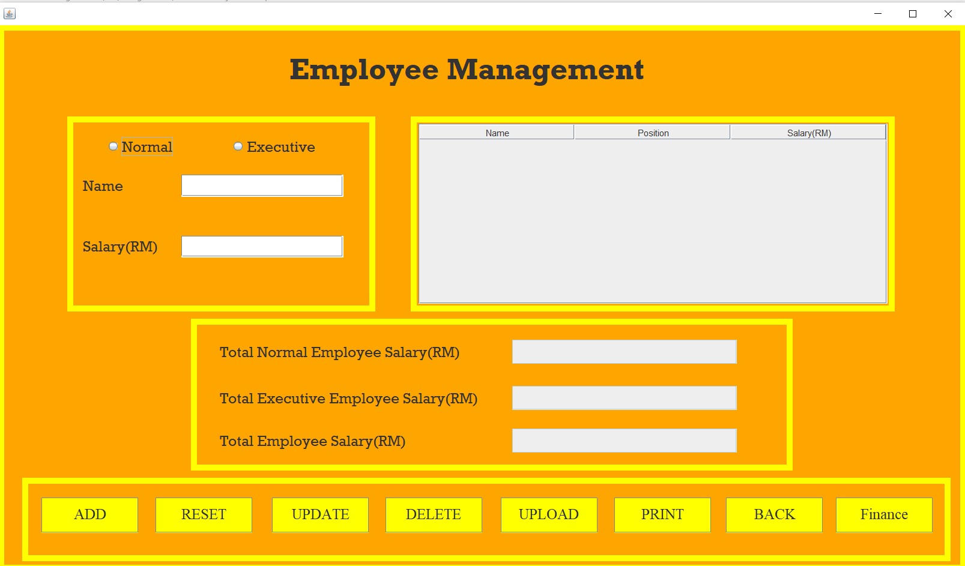

Choosing Finance button at Employee Management will bring to Finance GUI

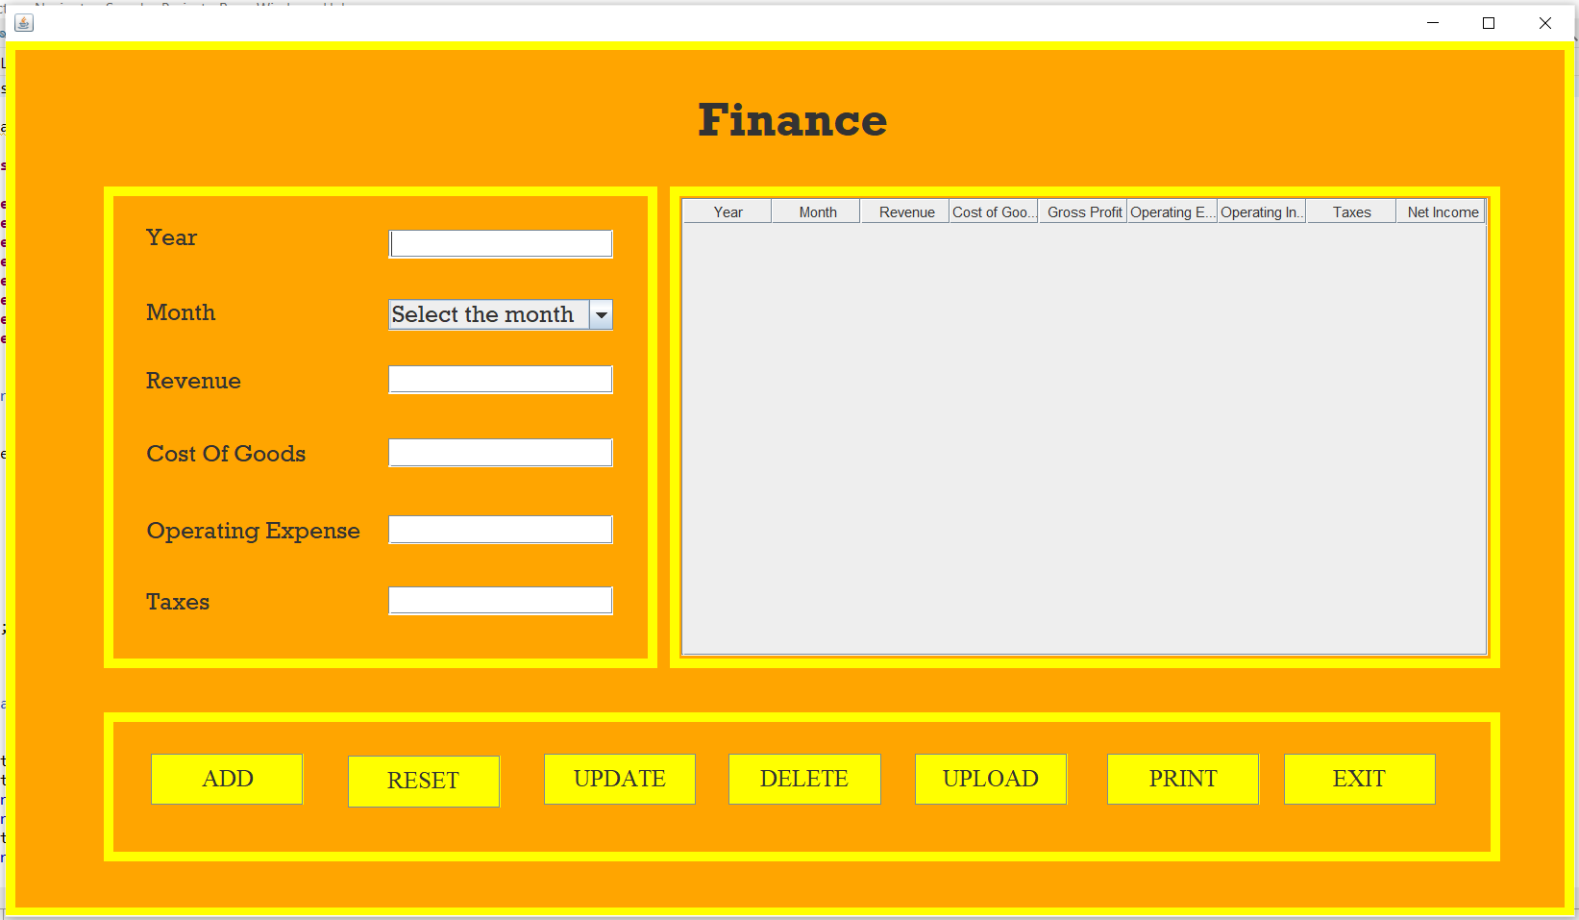

Billing GUI if the user is a Customer

